Report
Of
Data Analysis
Submitted
To
School of Computer Science and Engineering
IILM University, Greater Noida, U.P.
In partial fulfilment of the requirement of degree of
B.Tech CSE


By

Roll Number of Student: CS-2341523
Name of Student: DIVYANSHU PAL
Programme: B.Tech Computer Science Engineering, 7th Semester

Batch: 2026-27

CANDIDATE'S DECLARATION
I, DIVYANSHU PAL, Enrolment Number CS-2341523, do hereby declare that the internship report titled “Data Analysis” has been completed by me to fulfil the requirement for the award of the degree of Bachelor of Technology in Computer Science Engineering. All the references have been quoted and I have not taken as such any material from any other source. I affirm that this report is my own work and has not been submitted to any other institute for any degree/diploma requirement, and further I shall be solely responsible for any kind of copyright violation in this regard.

Signature: ________________________
Student Name: DIVYANSHU PAL
Enrolment/Roll No.: CS-2341523
Class- 4CSE8

ACKNOWLEDGEMENT
I am using this opportunity to express my gratitude to everyone who supported me throughout the Internship Program. I am thankful for their aspiring guidance, invaluably constructive criticism and friendly advice during this work. I am sincerely grateful to them for sharing their truthful and illuminating views on a number of issues related to this work.
I would like to thank Deloitte and the Forage platform for providing me the opportunity to undertake the “Data Analytics Job Simulation”, which gave me practical exposure to real-world data analysis and forensic technology tasks. I would also like to thank the faculty of the School of Computer Science and Engineering, IILM University, Greater Noida, for their constant support and encouragement throughout this internship.
I express my gratitude to my parents for their blessings.

Signature: ________________________
Student Name: DIVYANSHU PAL
Roll No.: CS-2341523

TABLE OF CONTENTS
Chapter No. | Chapter Name | Page Nos.
 | Cover Page | ---
1. | Candidate's Declaration | i
2. | Acknowledgement | ii
3. | Internship Completion Certificate | iii
4. | Project Description
 | 4.1 Introduction | 1
 | 4.2 Organization Profile | 2
 | 4.3 Problem Statement | 3
 | 4.4 Project Objectives | 4
 | 4.5 Scope of the Project | 5
 | 4.6 Technologies and Tools Used | 6
 | 4.7 System Architecture | 7
 | 4.8 Methodology | 8
 | 4.9 Expected Outcomes | 9
 | 4.10 Certificate of Completion and Communication Proof | 10
5. | Bibliography / References | 11

INTERNSHIP COMPLETION CERTIFICATE
The following certificate has been issued by Deloitte (through the Forage virtual experience platform) in recognition of the successful completion of the Data Analytics Job Simulation by DIVYANSHU PAL, covering practical tasks in Data Analysis and Forensic Technology, during the month of September 2026.
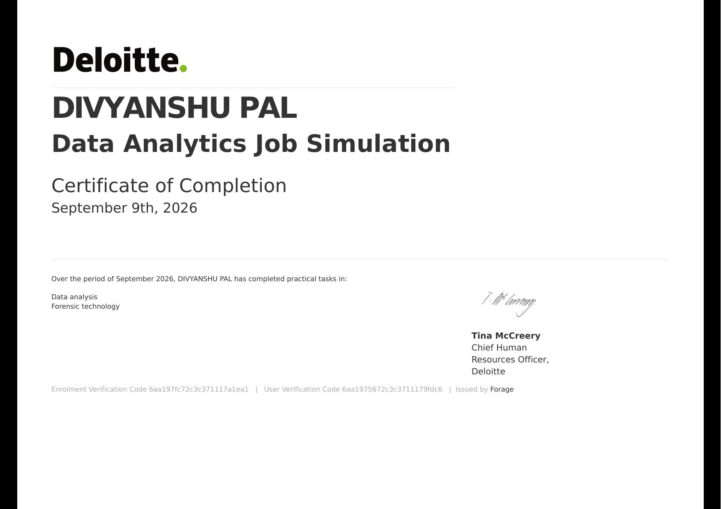
Enrolment Verification Code: 6aa197fc72c3c371117a1ea1 | User Verification Code: 6aa1975672c3c3711179fdc6 | Issued by Forage

PROJECT DESCRIPTION

4.1 Introduction
As part of the curriculum requirement of the B.Tech Computer Science Engineering programme (7th Semester) at the School of Computer Science and Engineering, IILM University, Greater Noida, I undertook an industry-oriented internship in the domain of Data Analysis. The internship was completed in the form of the “Deloitte Data Analytics Job Simulation”, hosted and delivered through the Forage virtual work-experience platform, during September 2026. This simulation replicates the real tasks performed by Data Analysts and Forensic Technology professionals at Deloitte, allowing participants to apply analytical thinking, data visualisation and investigative techniques to realistic business scenarios.
The internship provided an opportunity to work with data sets, business intelligence tools and forensic investigation techniques used in industry, thereby bridging the gap between classroom learning and practical application of data analytics concepts.

4.2 Organization Profile
Deloitte is one of the “Big Four” global professional services networks, offering services in the areas of audit and assurance, consulting, financial advisory, risk advisory, tax and legal services to clients across the world. Deloitte's Forensic and Financial Advisory practice, in particular, specialises in forensic technology, fraud investigation, data analytics and dispute resolution, helping organisations detect, investigate and prevent financial crime using advanced analytical tools and techniques. The Data Analytics Job Simulation used for this internship was designed by Deloitte's professionals and delivered through Forage, a platform that partners with leading global companies to offer virtual, self-paced job simulations to students.

4.3 Problem Statement
Organisations today generate large volumes of structured and unstructured data, and the ability to convert this data into actionable insight is critical for decision-making, fraud detection and business strategy. The simulation was built around two realistic problem scenarios faced by Deloitte's forensic and analytics teams:
(i) Forensic Technology Task: Building a dashboard to help the forensic team review and analyse large volumes of transactional/telecom data in order to identify unusual patterns, discrepancies or potential indicators of fraud.
(ii) Data Analysis Task: Analysing a business data set, drawing out meaningful insights and communicating findings and recommendations clearly to non-technical stakeholders through a written memo.

4.4 Project Objectives
• To understand how forensic technology and data analytics are applied to real business and investigative problems.
• To design and build a data dashboard capable of highlighting anomalies and trends within a given data set.
• To perform exploratory data analysis and derive actionable insights from raw data.
• To develop the skill of communicating technical findings to a non-technical audience in a clear, structured manner.
• To gain first-hand exposure to the working style, tools and expectations of a professional analytics/forensic team.

4.5 Scope of the Project
The scope of the internship was limited to the two structured modules provided within the Deloitte Data Analytics Job Simulation on Forage. It involved working with a sample/simulated data set (rather than live client data), building a single dashboard for anomaly identification, and preparing a data-analysis memo summarising findings. The exercise focused on developing conceptual and practical understanding of the analytics workflow — from raw data to insight to communication — rather than deployment of a production-grade system.

4.6 Technologies and Tools Used
• Spreadsheet software (Microsoft Excel) for data cleaning, sorting and preliminary analysis.
• Tableau for building interactive dashboards and visualisations for the forensic technology task.
• Basic statistical and analytical techniques for identifying trends, outliers and anomalies in data.
• Word-processing tools for documenting insights and preparing the analytical memo.

4.7 System Architecture
The overall workflow followed a standard data-analytics pipeline: (1) Data Collection – the simulated raw data set was provided; (2) Data Cleaning and Preparation – removing inconsistencies and structuring data for analysis; (3) Data Analysis – identifying trends, patterns and anomalies using spreadsheet functions and visual exploration; (4) Dashboard/Visualisation Layer – building an interactive Tableau dashboard to present findings visually; and (5) Reporting Layer – summarising insights and recommendations in a written memo for stakeholders. This layered flow — data source, processing layer, analysis layer and presentation layer — mirrors the architecture typically used in real-world business-intelligence and forensic-analytics systems.

4.8 Methodology
1. Reviewed the business context and requirements provided for each task in the simulation.
2. Collected and examined the provided data set to understand its structure and quality.
3. Cleaned and organised the data to remove errors, duplicates and inconsistencies.
4. Performed exploratory analysis to identify patterns, trends and outliers relevant to the forensic and business questions posed.
5. Built a dashboard in Tableau to visually represent the findings for the forensic technology task.
6. Drafted a structured memo summarising the key insights and recommendations for the data-analysis task.
7. Submitted the completed tasks on the Forage platform for automated review and feedback, and iterated based on the feedback received.

4.9 Expected Outcomes
• A working understanding of how forensic technology teams use dashboards to detect anomalies and potential fraud.
• Hands-on experience in exploratory data analysis and data visualisation using industry-standard tools.
• Improved ability to translate data-driven findings into clear, actionable business recommendations.
• Practical exposure to the expectations and workflow of a professional data-analytics role at a global organisation.
• A completed, verifiable certificate of completion from Deloitte, issued via Forage.

4.10 Certificate of Completion and Communication Proof
The Certificate of Completion issued by Deloitte's Chief Human Resources Officer, Ms. Tina McCreery, through the Forage platform, confirming successful completion of the Data Analytics Job Simulation, has been attached in Chapter 3 (Internship Completion Certificate) of this report. The certificate can also be independently verified using the Enrolment Verification Code and User Verification Code printed on it, or via the simulation link: https://www.theforage.com/simulations/deloitte-au/data-analytics-s5zy.

BIBLIOGRAPHY / REFERENCES
Deloitte. (2026). Data Analytics Job Simulation on Forage. Retrieved from https://www.theforage.com/simulations/deloitte-au/data-analytics-s5zy
Forage. (2026). Certificate of Completion – Data Analytics Job Simulation, Deloitte. Issued to Divyanshu Pal.
Deloitte. (2026). About Deloitte. Retrieved from https://www.deloitte.com
Tableau Software. (2026). Tableau Desktop Documentation. Retrieved from https://help.tableau.com
Microsoft. (2026). Excel Documentation. Retrieved from https://support.microsoft.com/excel

